**PT21A01 1CH PT100 temperature sensor**

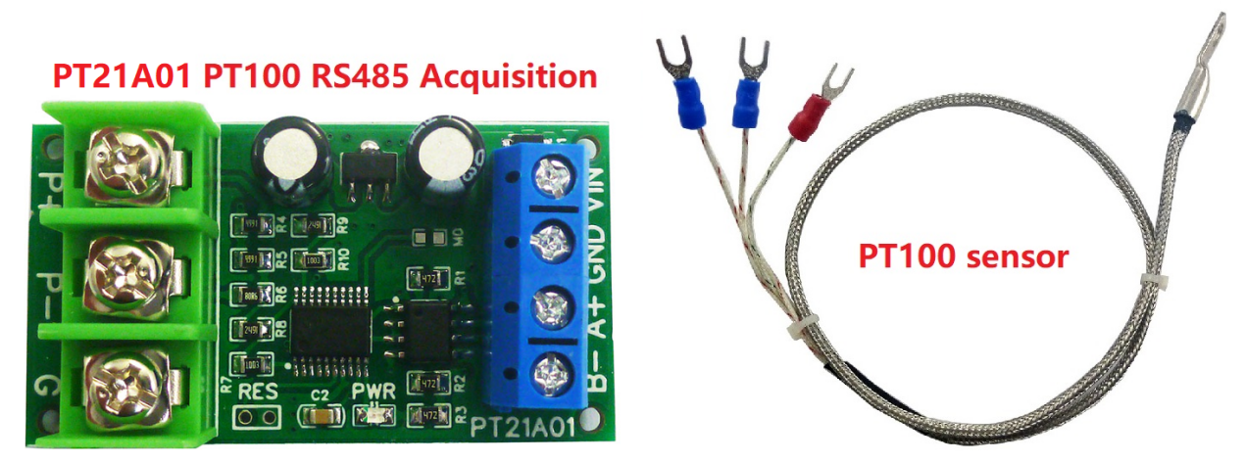

**Demo : https://youtu.be/suhoAk8Lt-8**

**PT21A01 PT100 RS485 Acquisition module Description:**

Working voltage: DC 6-25V (12V recommended)

Working current: 9-15MA

MODBUS RTU protocol, 03 read command, 06 / 16 write command.

Serial port baud rate: 9600 (default), N, 8, 1

By modifying the RS485 address, up to 247 modules can be cascaded (more than 16 please use R485 repeater)

Can read temperature and PT100 resistance value

Adapted sensor: PT100 3-wire or 2-wire sensor

Temperature measurement range: A version -40℃ to +220℃; B version -40℃ to +500℃. It is recommended to select a version with a smaller range within the range that meets the measurement.

Temperature measurement accuracy: 1%.

Size: 49 X 27 X 15MM

Weight: 13g

**New features (compared to the old version PTA9B01):**

1 Baud rate can be set: 1200 2400 4800 19200 38400 57600 115200 BPS

2 Check digits can be set: None, Even Parity, Odd Parity

3 Add Fahrenheit temperature

4 Add 16 (0X10) function codes

5 Add RES hardware reset function

Note: The module will restore factory settings and restart automatically after 5 seconds of shorting the RES port.

MODBUS RTU protocol please refer to : "PT21A01 PT22B01 Modbus RTU Protocol"

**PT100 sensor specifications:**

Type: PT100

Probe Diameter: 6.5mm

Probe Length: 30mm

Probe Material: Stainless steel

Cable Length: 0.5M

PTFE sheath 3-Wire type

Temperature -200~550°C degree

**Wiring diagram:**

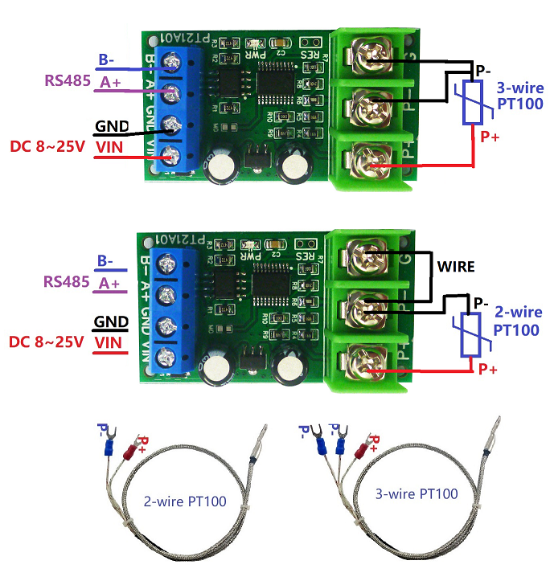

3-wire probe wiring mode: the red wire is connected to P+, and the other two wires of the same color are connected to P- and GND (the ports are not distinguished).

2-wire probe wiring mode: The red line is connected to P+, the blue line is connected to P-, and the P- and GND are connected with a wire.

**RS485 bus wiring diagram:**

